Test case: 1 - Check whether it accepts negative numbers

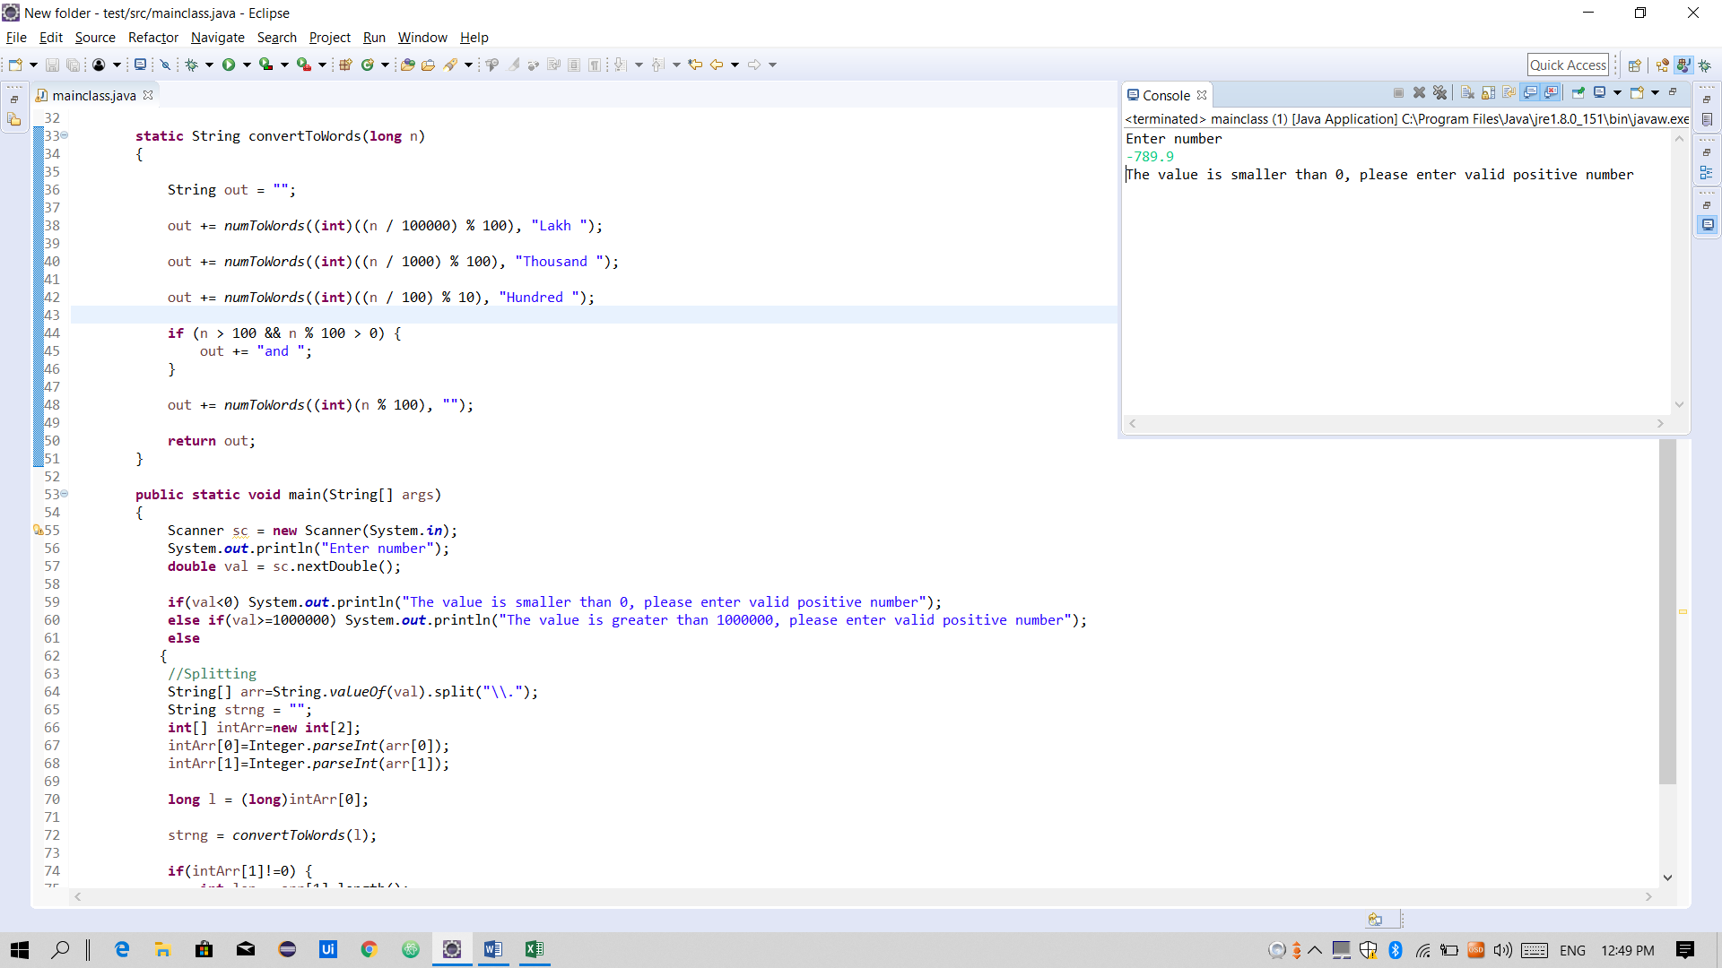

Test Case 2 - Check whether it accepts input value greater than 10lakh

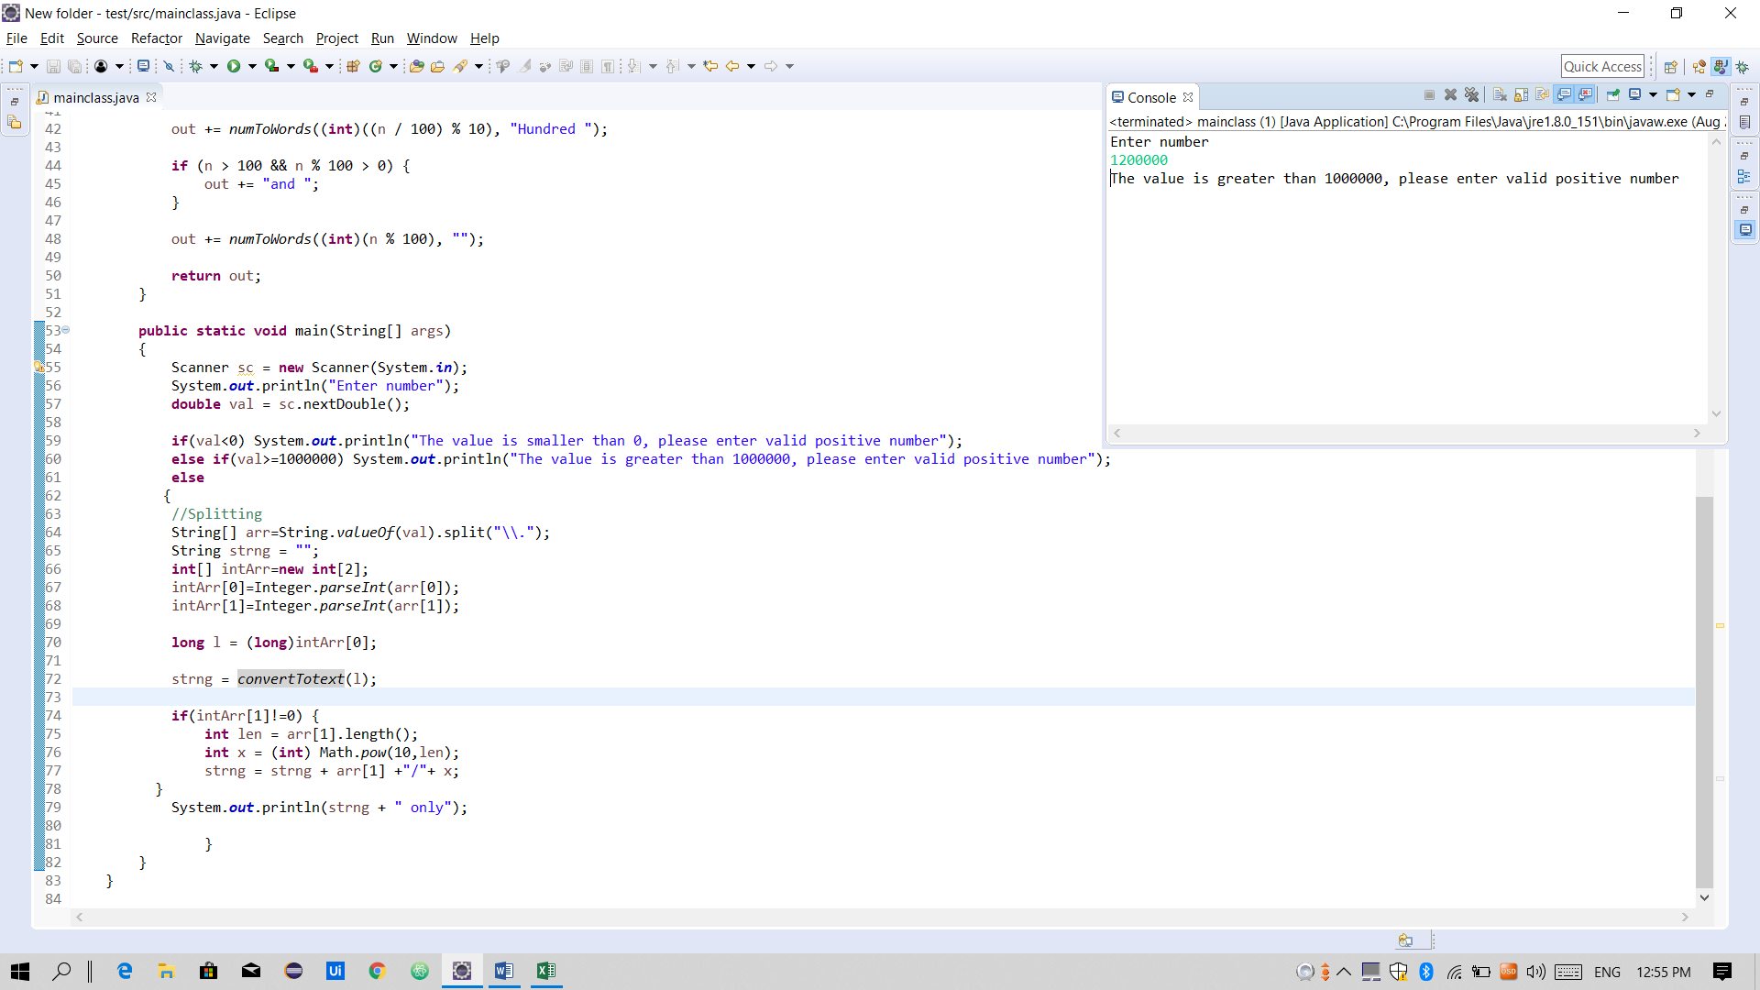

Test Case 3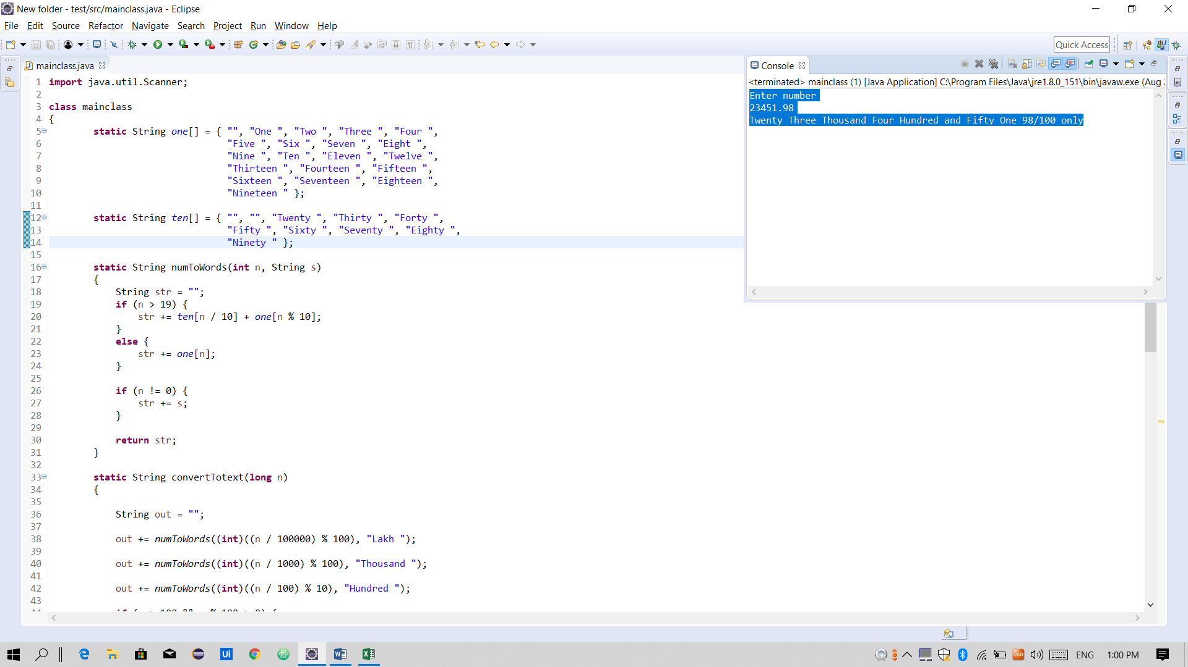 - Check whether it prints the desired output as given in the requirement

Test Case 4 - Check whether it accepts only decimal numbers

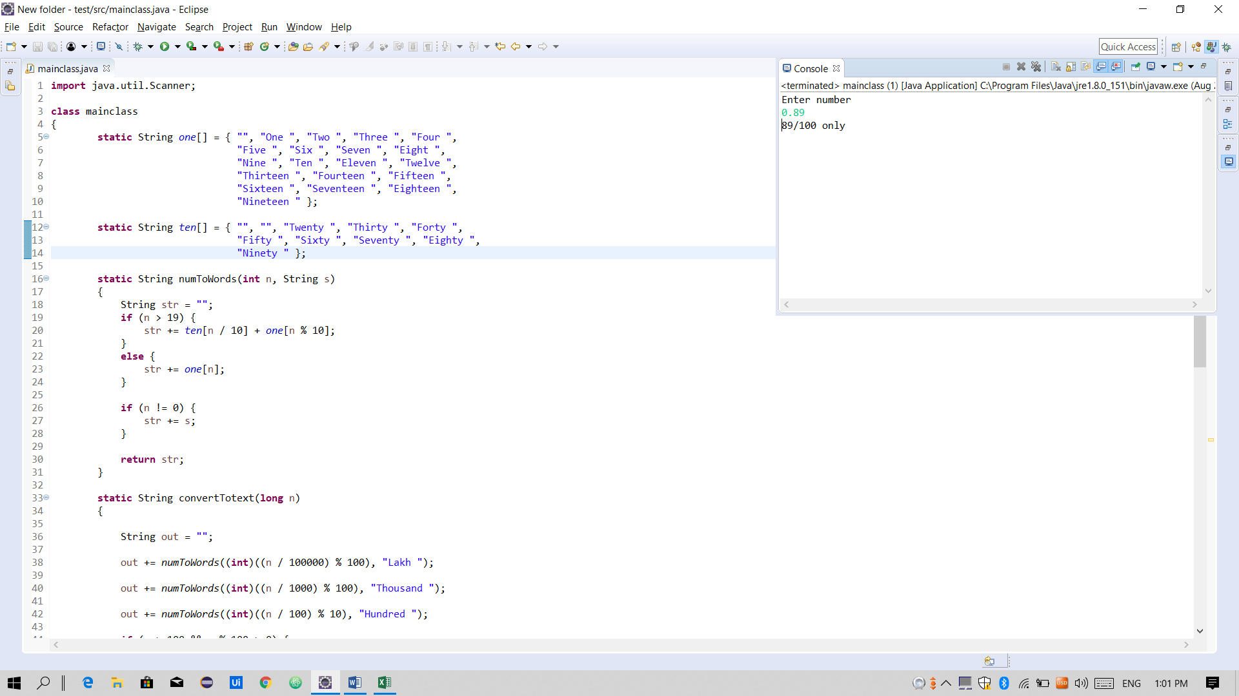

Test Case 5 - Check whether it accepts only positive numbers

